The Watcher XML File Saving

Abstract

This document intented to explain and outline steps needed to enable theWatcher to save watchpoint to xml file(s).

What needed to be done

1) coder must map a watchpoint tree-node to a xml file using radDbgWatchAssociateFile
For example:
- xml file mapped “fog.xml” must be already existed on disk, and have approiated entry entered.
For exmample:
in theWatcher namespace, it looks like the following
//
// initalize watcher subsystem
//
radDbgWatchInitialize( "\\" );
//
// map "\\game\\fog" tree node to fog.xml
//
radDbgWatchAssociateFile("\\game\\fog", "fog.xml");
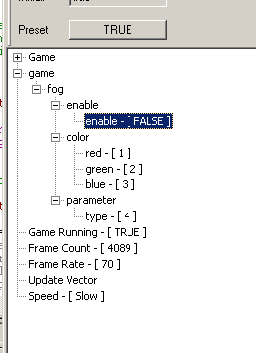
coder mapped \\game\\fog into the fog.xml, and fog.xml will be look like the following
Note: If any watchpoint is not in the xml file, then the watchpoint cannot be saved into the xml file, you will notice that because the “save button” will be disabled in this case.
<fog>
<enable enable="true"/>
<color red="1" green="2" blue="3"/>
<parameter type="4"/>
</fog>
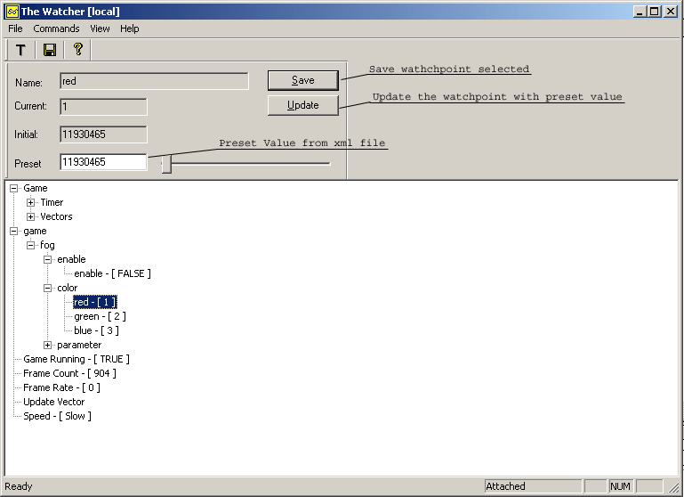
- Saving Watchpoint, and Preset a Saved Watchpoint
To save a watchpoint, select a data, and press save button, or press “save all” button on the toolbar.
To load a watchpoint, select a data, then the preset value will be loaded from xml file into preset edit box. Then user can press update button to set the value in game.

